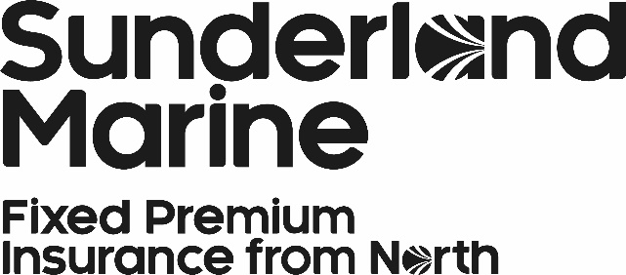

Aquaculture Proposal Form
Multi-Site Proposal
Checklist: Please make sure to include the following with your submission | Completed
- Indemnity scale to reflect cost of production
- Production plan (by site)
- Equipment inventory (by site)
- Under Section 3 “Insurance Required”, please indicate whether the production system is cage, land-based or recirculation.
Please note: there are extra pages at the back of this proposal form for any additional information

Explanatory Information
The checklist and completed proposal form are necessary to correctly evaluate each operation. Failure to submit the information requested may result in delays, the indication of more restrictive terms or a disinclination to cover. Please note that this checklist is not definitive; our risk managers and underwriters may request additional information to help analyse the risk. Likewise you should include any additional information that you feel may be relevant to this submission.

Company / Site Information
Company
Company Name

Contact Name
Position

Company Mailing Address
Postcode

Tel No |  | Email

Sites
Name of sites to be Insured  (please indicate whether hatchery, land-based or cages) | Location (Lat & Long) | Site Licence No.

(Continue on ‘Additional Information’ pages if necessary)
Contact Details
Please provide the contact details for staff within this company responsible for:
Production
First Name
Surname
Position
Email
Mobile No
Office Location
Health
First Name
Surname
Position
Email
Mobile No
Office Location
Engineering
First Name
Surname
Position
Email
Mobile No
Office Location
Insurance and Claims
First Name
Surname
Position
Email
Mobile No
Office Location

Insurance Required
Stock (for the period of the policy):
Stock: Insurance Required | Yes | No

Freshwater
Species | Number | Production system | Start weight | End weight | Value

Seawater
Species | Number | Production system | Start weight | End weight | Value

Currency

Equipment
Cages: Insurance Required | Yes | No

Manufacturer | Material | Number | Year of Manufacture | Value

Currency

Barges: Insurance Required | Yes | No

Manufacturer | Use | Number | Year of Manufacture | Value

Currency

Nets: Insurance Required | Yes | No

Manufacturer | Material | Number | Year of Manufacture | Freshwater or Seawater | Value

Currency

Vessels: Insurance Required | Yes | No

Manufacturer | Size | Number | Year of Manufacture | Value

Currency

Health

Frequency of Health Checks: |  | Conducted By:
Please detail any routine or prophylactic treatments.
Fallow Period
Retained Vet Details
What are the fish vaccinated against?

Loss History
Please indicate any losses, irrespective of whether or not it resulted in a claim, noting the site, causation, number and size of fish lost and the settlement, in the last 5 years.
Date | Cause of Loss | Species | Number | Average Weight | Gross Loss (£) | Nett Settlement  (£)

Insurance History

Name of Present Insurer |  | Renewal Date

In respect of the property, the subject of this proposal has any insurer:
- DECLINED: YES NO
- CANCELLED COVER: YES NO
- IMPOSED RESTRICTED TERMS OR ADDITIONAL PREMIUMS: YES NO

If so, please provide details

Please provide any other information which you feel may be relevant to the application for insurance

Additional Information

Additional Information

SIGNING THIS FORM DOES NOT BIND THE PROVIDER OR INSURER TO COMPLETE THE INSURANCE, BUT IT IS AGREED THAT THIS PROPOSAL SHALL BE THE BASIS OF THE INSURANCE CONTRACT ENTERED INTO WITH THE COMPANY.

I HEREBY DECLARE THAT THE PARTICULARS AND ANSWERS GIVEN IN THIS PROPOSAL ARE IN EVERY RESPECT TRUE AND CORRECT AND THAT I HAVE NOT WITHHELD OR MISREPRESENTED ANY INFORMATION CALCULATED TO INFLUENCE THE DECISION OF THE COMPANY IN REGARD TO THE UNDERWRITING OF THE RISKS TO WHICH THIS PROPOSAL RELATES.

FAILURE TO DISCLOSE ALL RELEVANT FACTS MAY INVALIDATE YOUR POLICY.

INSURERS SHOULD IMMEDIATELY BE ADVISED OF ALL MATERIAL CHANGES OR ALTERATIONS OF THE INFORMATION PROVIDED IN THIS PROPOSAL. A MATERIAL CHANGE IS ONE WHICH WOULD INFLUENCE THE JUDGEMENT OF A PRUDENT INSURER IN SETTING THE TERMS OR PREMIUMS OR DETERMINING WHETHER TO CONTINUE ACCEPTANCE OF THE RISK. FAILURE TO DO SO MAY INVALIDATE YOUR INSURANCE SHOULD WE AGREE TO ENTER INTO AN INSURANCE CONTRACT WITH YOU.

SIGNATURE: DATE:
PRINT NAME: POSITION:
COMPANY:
COMPANY ADDRESS:

Please return the completed and signed proposal forms to the following address:
Sunderland Marine
The Quayside
Newcastle upon Tyne
NE1 3DU

Tel: +44(0)191 232 5221
Fax: +44(0)191 261 0540

Alternatively please email the completed/signed proposal forms to robert.ferguson@sunderlandmarine.com

How We Use Your Data: Personal privacy is of paramount importance to us at the North Group. Our Privacy Notice can be found on our website at https://www.sunderlandmarine.com/privacy-policy/
This explains in detail how we collect and use personal data as well as explaining the rights of an individual as a data subject.

